Full Name: Ashvath Suresh Babu Priya

Date: 13-06-2023

**Market Segmentation Study - Steps 1, 2, 3, 4, and 5 Report**

**1. Introduction:**

Market segmentation is a fundamental concept in marketing strategy that involves dividing a broad target market into distinct groups with similar characteristics, needs, and behaviours. This report aims to present the findings and insights gained from studying the fundamentals of market segmentation. By focusing on Steps 1, 2, 3, 4, and 5 of the Market Segmentation PDF, we aim to develop a solid understanding of market segmentation and its implications for effective marketing strategies.

In today’s competitive business landscape, understanding the importance of market segmentation is crucial. It enables organisations to target specific customer segments effectively, customise their marketing efforts, and drive business growth. This report comprehensively analyses the critical steps involved in market segmentation and their practical applications.

We begin with Step 1, “Deciding (not) to Segment,” exploring the factors organisations consider when deciding whether to pursue market segmentation. By examining the benefits and drawbacks of segmentation, we gain insights into its potential impact on marketing strategies.

Moving on to Step 2, “Specifying the Ideal Target Segment,” we delve into identifying and defining the ideal target segment. By thoroughly examining criteria such as demographics, psychographics, and behavioural attributes, we understand the significance of aligning marketing efforts with the target audience’s needs, preferences, and motivations.

Step 3, “Collecting Data,” emphasises the importance of data collection in market segmentation. We explore various sources and methods to gather relevant information, highlighting the need for comprehensive, accurate, and reliable data to drive informed decision-making throughout the segmentation process.

Building upon the foundation laid by the previous steps, we proceed to Step 4, “Exploring Data,” and Step 5, “Extracting Segments.” In Step 4, we analyse the collected data using descriptive statistics, data visualisation, and exploratory data analysis techniques, which enables us to gain valuable insights and uncover patterns within the dataset. In Step 5, we apply segmentation methods to extract meaningful segments based on the identified criteria. Understanding each Segment’s characteristics, behaviours, needs, and preferences allows for developing targeted marketing strategies.

By completing this study task, we acquire the knowledge and skills necessary to contribute effectively to future market segmentation projects. Additionally, throughout the report, we will include examples and visualisations from the McDonald’s case study, further illustrating the practical application of market segmentation principles.

A solid understanding of market segmentation and its implications equips us to make informed decisions and drive business success in an increasingly dynamic and competitive marketplace.

**2. Strategic Considerations:**

In Step 1, we will explore the crucial factors that organisations consider when making the critical decision of whether or not to pursue market segmentation. Market segmentation involves dividing a broad target market into distinct consumer groups with similar characteristics, needs, and preferences. This crucial step sets the foundation for all subsequent segmentation efforts.

* *Benefits of Market Segmentation:*

Market segmentation offers several compelling benefits to organisations. By dividing the market into smaller, more homogeneous segments, companies can tailor their marketing strategies better to meet each Segment’s unique needs and preferences. Let us delve into some critical benefits of market segmentation:

* + **Enhanced targeting**: Segmentation allows companies to identify specific customer groups and develop targeted marketing messages and offers that resonate with those segments. For example, a fitness apparel company can create separate campaigns for fitness enthusiasts, yoga practitioners, and runners, focusing on their unique interests and needs.
  + **Improved customisation**: By understanding the distinct characteristics and preferences of different segments, companies can customise their products, services, and marketing efforts to meet the needs of each Segment better. This level of customisation can foster stronger customer loyalty and satisfaction.
  + **Efficient resource allocation**: Market segmentation helps organisations allocate their resources, such as marketing budgets and efforts, more efficiently by focusing on the segments with the highest potential for growth and profitability. This targeted approach ensures we utilise resources effectively to yield the best possible outcomes.
  + **Competitive advantage**: A well-executed segmentation strategy can provide a competitive advantage by allowing companies to differentiate themselves and establish stronger connections with their target customers. Companies can uniquely position their customers in the market by understanding them.
* *Drawbacks and Challenges:*

While market segmentation offers numerous benefits, it is essential to consider the potential drawbacks and challenges associated with segmentation efforts. Let us explore these considerations:

* + **Increased complexity**: Implementing market segmentation requires additional effort and resources to gather data, analyse it, and develop tailored marketing strategies for each Segment. This complexity can pose challenges, especially for smaller organisations with limited resources. Proper planning and effective utilisation of available resources can mitigate this challenge.
  + **Cost implications**: Segmentation efforts can be cost-intensive, especially if extensive data collection and analysis are involved. Companies must carefully weigh the potential return on investment against the costs associated with segmentation. Implementing cost-effective data collection methods and utilising available data sources can help manage expenses.
  + **Potential for oversimplification**: There is a risk of oversimplifying the market by creating segments that are too broad or based on superficial characteristics. Effective segmentation requires a deep understanding of customer behaviours, needs, and motivations. Conducting thorough market research and employing advanced analytics techniques can help avoid oversimplification.
  + **Market dynamics**: Markets constantly evolve, and customer preferences and behaviours can change. Therefore, maintaining accurate and up-to-date segment profiles is crucial for effective segmentation. Regular monitoring of market trends and continuous data analysis can ensure that segmentation strategies remain relevant and adaptable.
* *Decision Factors:*

When deciding whether or not to pursue market segmentation, organisations should consider various factors, including:

* + **Market heterogeneity**: If the market exhibits significant variations in customer characteristics, needs, or behaviours, segmentation can help companies better understand and target these differences. Conducting market research and analysing customer data can provide insights into market heterogeneity.
  + **Resource availability**: Segmentation efforts require time, budget, and skilled personnel. Organisations should assess whether they have the necessary resources to execute segmentation effectively. This evaluation will help determine the feasibility of pursuing segmentation at a given time.
  + **Marketing objectives**: The company’s marketing objectives and goals should align with the potential benefits of market segmentation. The relevance of segmentation increases when organisations prioritise objectives such as customisation, targeting, and improved resource allocation. Aligning segmentation efforts with overall marketing objectives ensures a strategic approach.
  + **Competitive landscape**: Analysing and understanding how competitors approach segmentation can provide insights into whether segmentation is necessary to gain a competitive advantage. Assessing the market positioning and strategies of competitors can guide decision-making regarding segmentation.

In Step 1, we explored the strategic considerations involved in deciding whether or not to pursue market segmentation. By carefully evaluating the benefits, drawbacks, and decision factors, organisations can make an informed decision that aligns with their marketing objectives and resources. This decision sets the stage for subsequent steps in the segmentation process, including specifying the ideal target segment and collecting relevant data.

**3. Defining the Optimal Target Segment:**

In Step 2, we focus on identifying and defining the ideal target segment for our marketing efforts. Specifying the target segment is crucial as it allows us to allocate our resources effectively towards the most relevant and profitable customer groups. By understanding the target segment’s characteristics, needs, and preferences, we can develop tailored marketing strategies that resonate with our ideal customers.

* *Identifying Target Segment Criteria:*

We must consider various criteria differentiating customer groups to specify the ideal target segment. These criteria include:

* + **Demographic factors**: Age, gender, income, education, and occupation are essential demographic characteristics that help us segment the market and tailor marketing messages and offers to suit specific customer preferences.
  + **Psychographic factors**: Personality traits, lifestyles, values, attitudes, and interests provide insights into consumers’ motivations, behaviours, and preferences. Analysing psychographic data helps us create more targeted marketing campaigns.
  + **Behavioural factors**: Customer behaviours, such as purchasing patterns, brand loyalty, product usage, and decision-making processes, can differentiate customer segments. Understanding behavioural patterns helps us develop effective marketing strategies.
  + **Geographic factors**: Geographic location, such as country, region, or urban vs. rural areas, can impact consumer needs and preferences. Geography plays a role in targeting customers with location-specific offers and messaging.
* *Research and Data Analysis:*

Once we have identified the criteria for the target segment, we need to conduct research and data analysis to understand the market and identify the most promising Segment. This research can involve primary and secondary data sources, such as surveys, interviews, market research reports, and industry publications. The data collected should provide insights into customer characteristics, behaviours, preferences, and market trends.

* *Segment Evaluation and Selection:*

After gathering the necessary data, we must evaluate and prioritise potential segments based on their attractiveness and fit with our objectives. Key considerations during this evaluation process include:

* + **Segment size and growth potential**: Assessing each Segment’s size and growth potential helps us determine the market opportunity and revenue potential.
  + **Segment profitability**: Understanding the profitability of each Segment, including factors such as purchasing power, price sensitivity, and lifetime value, helps us prioritise segments with higher profitability potential.
  + **Segment accessibility**: Evaluating the ease of reaching and engaging with each Segment is crucial. Distribution channels, media preferences, and communication channels influence segment accessibility.
  + **Compatibility with organisational capabilities**: We need to assess whether we have the resources, abilities, and expertise to serve the target segment effectively. Aligning the Segment’s needs with our offerings and strengths ensures a better fit.
* *Defining the Ideal Target Segment:*

Based on the evaluation and selection process, we can define the ideal target segment by creating a detailed profile with demographic, psychographic, behavioural, and geographic characteristics. This profile provides a clear understanding of the Segment’s needs, preferences, motivations, and pain points, allowing us to develop tailored marketing strategies.

Specifying the ideal target segment is critical in our market segmentation process. By understanding the market segmenting criteria, conducting thorough research and analysis, evaluating potential segments, and defining the target segment, we can allocate our resources effectively and develop marketing strategies that resonate with our ideal customers. This strategic approach enhances the effectiveness and efficiency of our marketing initiatives, leading to improved customer satisfaction, loyalty, and business growth.

**4. Data Collection:**

This step emphasises the importance of collecting relevant and reliable data to support market segmentation. Effective data collection allows organisations to gain insights into customer behaviours, preferences, and characteristics, enabling them to make informed decisions about segmentation strategies and targeted marketing efforts.

* *Data Collection Methods:*

To collect data for market segmentation, organisations can employ various methods. Here are some standard techniques with examples:

* + **Surveys**: Conduct online, email, or in-person surveys to gather customer information. Use structured questionnaires with both closed-ended and open-ended questions to obtain valuable insights.
  + **Interviews**: Conduct one-on-one interviews with customers or industry experts. These interviews can be face-to-face, over the phone, or through video calls, allowing in-depth exploration of customer needs, preferences, and motivations.
  + **Focus groups**: Bring together a small group of individuals representing the target market segment for guided discussions. Gather qualitative data and capture participants’ perspectives.
  + **Observation**: Observe customer behaviours by tracking website usage, in-store observations, or social media interactions. Gain valuable insights into customer preferences and behaviours.
  + **Secondary data sources**: Leverage existing data from market research reports, industry publications, government sources, and databases to supplement primary data collection efforts.
* *Data Variables:*

When collecting data for market segmentation, consider the variables that provide meaningful insights into customer characteristics and behaviours. Some standard variables include:

* + **Demographics**: Age, gender, income, education, occupation, and marital status help understand the profile of the target audience.
  + **Psychographics**: Explore customers’ values, attitudes, interests, opinions, and lifestyles. Gain insights into their motivations, preferences, and decision-making processes.
  + **Behavioural data**: Focus on customers’ past behaviours, such as purchase history, brand loyalty, product usage, and interactions with marketing channels. Understand customer engagement and response patterns.
  + **Geographic data**: Consider customers’ physical location, country, region, city, and neighbourhood. Reveal regional preferences and local market dynamics.
* *Ensuring Data Quality:*

To ensure the reliability and validity of collected data, follow these practices:

* + Clearly define research objectives and the specific data needed to address those objectives.
  + Use well-designed questionnaires or interview guides that capture relevant information.
  + Ensure the sample size is adequate and representative of the target market segment.
  + Implement quality control measures to minimise errors in data collection.
  + Validate the data through cross-referencing multiple sources or conducting pilot studies.
  + Maintain data privacy and adhere to relevant data protection regulations.
* *Data Analysis and Interpretation:*

Once data is collected, organisations need to analyse and interpret the findings to derive meaningful insights. This analysis may involve quantitative techniques, such as statistical analysis or clustering algorithms, as well as qualitative analysis of open-ended responses or interview transcripts. The goal is to identify patterns, trends, and relationships within the data to inform the segmentation strategy.

Organisations comprehensively understand their target market segment by collecting relevant and reliable data. This knowledge serves as a foundation for effective segmentation and enables the development of tailored marketing strategies that resonate with the identified segments.

**5. Data Exploration:**

In Step 4, we explored the collected data to gain valuable insights and uncover patterns that inform the market segmentation. By delving into the data, we aimed to understand our target audience’s characteristics, behaviours, and preferences more deeply, enabling us to develop effective segmentation strategies and targeted marketing initiatives.

* *Data Cleaning and Preparation:*

To ensure the data’s quality and usability, we cleaned and prepared it, which involved several essential steps:

* + Removing duplicates, inconsistencies, and errors from the dataset.
  + Handling missing data by imputing or removing incomplete records.
  + Standardising and formatting variables for consistency and ease of analysis.
  + Transforming and encoding variables as necessary for statistical analysis or modelling.
* *Descriptive Statistics:*

Descriptive statistics played a vital role in summarising the data and identifying key characteristics of our target market segment. We utilised various descriptive statistics techniques, including:

* + Measures of central tendency such as mean, median, and mode provided insights into variables’ average or typical values.
  + Measures of dispersion, like standard deviation, range, and interquartile range, indicated the variability or spread of data.
  + Frequency distributions in the form of frequency tables or histograms helped us visualise the distribution of values within variables and identify any patterns or anomalies.
* *Visualisation Techniques:*

Data visualisation proved a powerful tool for exploring and presenting data visually. It allowed us to understand better the dataset’s relationships, trends, and patterns. We utilised the following visualisation techniques:

* + Bar charts and pie charts represent categorical variables and compare frequencies or proportions.
  + Histograms and box plots to analyse the distribution and spread of continuous variables.
  + Scatter plots display the relationship between two continuous variables, facilitating the identification of correlations or trends.
  + Heatmaps and correlation matrices depict the strength and direction of relationships between multiple variables.
* *Data Segmentation and Clustering:*

As part of data exploration, we also employed segmentation and clustering techniques to uncover meaningful customer segments and patterns within the data. We applied segmentation techniques, such as demographic segmentation or behavioural segmentation, to identify distinct customer groups. Additionally, clustering algorithms like k-means or hierarchical clustering automatically grouped similar observations based on selected variables.

* *Hypothesis Testing:*

To validate or challenge our initial assumptions, we utilised hypothesis testing, which allowed us to test assumptions or claims about our target market segment. Statistical tests such as t-tests or chi-square tests were employed to evaluate relationships between variables and determine if they were statistically significant. Hypothesis testing guided further analysis and decision-making.

Data exploration gave valuable insights into customer behaviours, preferences, and characteristics. These insights served as a foundation for developing meaningful market segments and informed the development of targeted and personalised marketing strategies.

**6. Segment Extraction:**

Step 6 focuses on extracting distinct segments from the collected data to create meaningful and actionable market segments. Segment extraction involves utilising various techniques and methods to identify groups of customers with similar characteristics, behaviours, and preferences. These segments are the foundation for targeted marketing strategies and customised approaches to engage with different customer groups.

* *Segmentation Techniques:*

To extract segments from the data, organisations can employ different segmentation techniques, including:

* + **Demographic Segmentation**: Dividing customers based on demographic variables such as age, gender, income, education, occupation, and marital status helps understand the different needs and preferences of various demographic groups.
  + **Psychographic Segmentation**: Focusing on customers’ attitudes, values, interests, opinions, and lifestyles allows for creating segments based on psychographic profiles, which delves into their motivations, aspirations, and decision-making processes.
  + **Behavioural Segmentation**: Categorising customers based on their past behaviours, such as purchase history, brand loyalty, product usage, and response to marketing stimuli, helps identify distinct segments with specific behavioural patterns.
  + **Geographic Segmentation**: Dividing customers based on their geographic location, including country, region, city, or neighbourhood, considers regional preferences, cultural influences, and local market dynamics to create targeted segments.
* *Segmentation Criteria:*

When extracting segments, it is essential to establish the criteria for segment formation, considering factors such as:

* + **Homogeneity**: Segments should be internally homogeneous, with customers within each Segment sharing similar characteristics and behaviours.
  + **Distinctiveness**: Segments should be distinct, exhibiting noticeable differences in preferences, needs, or behaviours.
  + **Measurability**: Segments should be identifiable and measurable, enabling effective targeting and evaluation of marketing efforts.
  + **Actionability**: Segments should be actionable, allowing organisations to develop tailored marketing strategies and initiatives for each Segment.
* *Data Analysis and Modelling:*

Data analysis techniques and statistical modelling play a crucial role in segment extraction. Some commonly used methods include:

* + **Cluster Analysis**: This statistical technique groups similar observations based on selected variables, identifying natural clusters or segments within the data.
  + **Factor Analysis**: By exploring underlying factors or dimensions that explain variability in the dataset, factor analysis uncovers latent variables contributing to segment formation.
  + **Decision Trees**: Decision trees ultimately lead to the formation of segments by using a hierarchical structure to split the data based on specific variables.
  + **Latent Class Analysis**: Identifying unobserved or latent classes within the dataset, latent class analysis allows for identifying distinct segments based on a combination of observed variables.
* *Segment Profiling:*

Once organisations extract segments, they need to profile each Segment to understand its unique characteristics and behaviours. Segment profiling involves analysing and describing the key attributes of each Segment, such as demographic profiles, psychographic traits, behavioural patterns, and purchasing preferences. This information helps tailor marketing strategies and messages to resonate with each Segment’s needs and preferences.

* *Validation and Refinement:*
* Segment extraction is an iterative process that requires validation and refinement. Organisations should assess the validity and effectiveness of the extracted segments by evaluating their predictive power, stability over time, and responsiveness to marketing interventions. If necessary, segments can be refined or adjusted based on additional data or feedback from customers.

By extracting segments from the data, organisations can better understand their target audience and create targeted marketing strategies. These strategies allow for personalised and relevant communication, ultimately improving customer satisfaction, engagement, and business growth.

**7. Interpretation and Implications:**

In this section, we will interpret the findings from the market segmentation analysis and discuss their implications. Based on the performed data exploration and segment extraction, we can draw the following interpretations and impact:

* *Identified Customer Segments:*
  + We have identified distinct customer segments within the dataset through market segmentation analysis.
  + These segments represent different groups of customers with unique characteristics, needs, and preferences.
  + Understanding these segments allows for targeted marketing strategies, customised product offerings, and improved customer experiences.
* *Segment Characteristics:*
  + Each customer segment exhibits specific traits and behaviours that differentiate them from others.
  + For example, one Segment might be price-sensitive, while another prioritises convenience and quality.
  + By understanding these characteristics, businesses can tailor their marketing messages and product features to resonate with each Segment.
* *Market Opportunities:*
  + The identified segments present valuable market opportunities for businesses.
  + Companies can allocate resources effectively and maximise their market penetration by focusing on specific segments with high growth potential.
  + Additionally, recognising emerging trends within segments can help businesses stay ahead of competitors and adapt to changing consumer preferences.
* *Personalisation and Customer Satisfaction:*
  + Market segmentation enables personalised marketing and improved customer satisfaction.
  + By delivering targeted messages and offers to each Segment, businesses can enhance the relevance and effectiveness of their marketing campaigns.
  + Customising products and services based on segment preferences can increase customer satisfaction and loyalty.
* *Strategic Decision-Making:*
  + The insights gained from market segmentation analysis can inform strategic decision-making within the organisation.
  + Businesses can allocate resources, prioritise product development efforts, and optimise pricing strategies based on the needs and preferences of different customer segments.
  + By aligning business strategies with segment characteristics, companies can enhance their competitive advantage and drive long-term growth.

Overall, the market segmentation analysis interpretation provides valuable insights into customer behaviour, preferences, and market dynamics. By leveraging these insights, businesses can make informed decisions, develop targeted marketing strategies, and deliver personalised experiences to different customer segments, which leads to improved customer satisfaction, increased market share, and sustainable business growth.

**8. Examples and Visualisations:**

In this section, I will showcase the examples and visualisations based on my work replicating the McDonald’s Case Study in Python. The dataset contains information about customers, including their gender, age, and preferences for various menu items. The analysis aims to identify natural groupings or clusters of customers based on their preferences and characteristics.

* *Data Exploration*

We first loaded the dataset using the `load_data` function to begin the analysis. The dataset consists of customer information such as gender, age, and responses to questions about menu items. We displayed the first few rows of the data using the `display_data` function, which provided an overview of the variables and their values. Additionally, we used the `display_data_info` function to get information about the data, such as the column data types and non-null values.

After examining the data, we checked for missing values using the `display_null_values` function. Fortunately, there were no missing values in the dataset. To gain further insights, we computed descriptive statistics using the `display_descriptive_stats` function, which provided summary statistics such as mean, standard deviation, minimum, maximum, and quartiles for numerical variables.

* *Data Visualisation*

To visualise the data, we created several plots. First, we plotted the count of male and female customers using a pie chart. This chart displayed the distribution of genders among the customers. We used the `plot_gender_count` function for this visualisation.

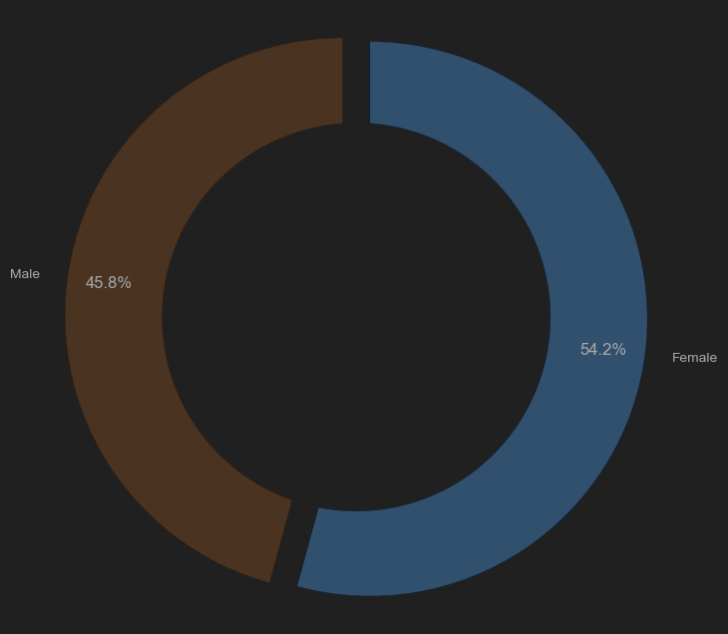

Next, we plotted the count of customers in different age groups using a bar chart. The `plot_age_count` function allowed us to visualise the distribution of customers across different age categories. This plot provided insights into the age composition of the customer base.

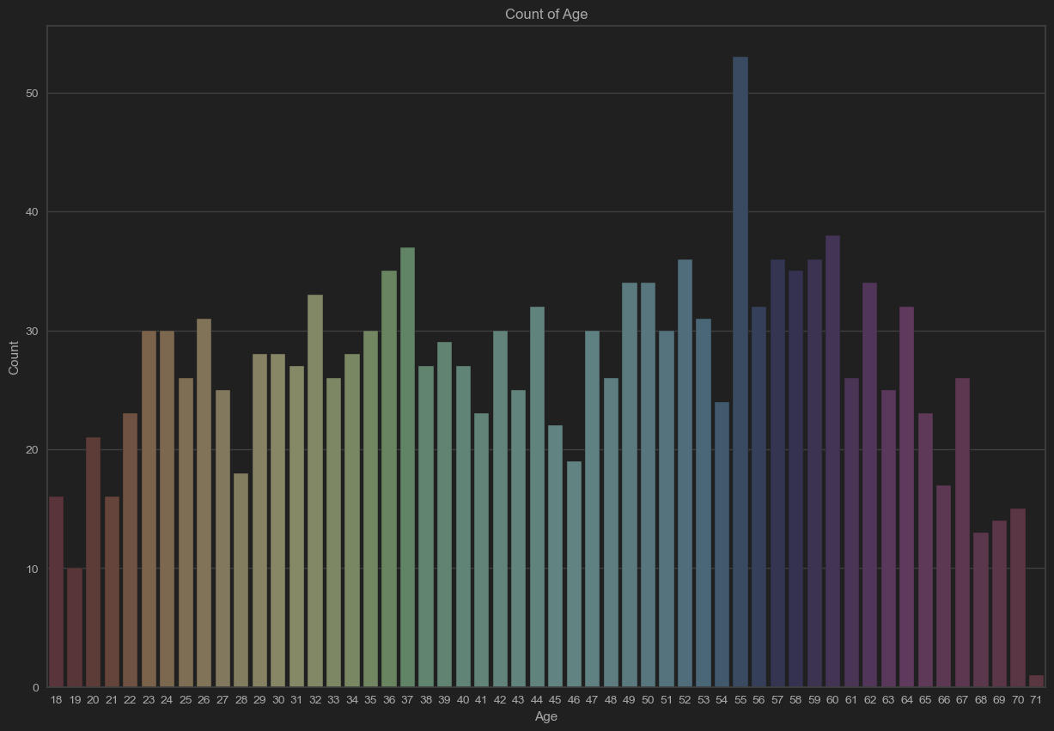

* *Data Preprocessing*

We used the `preprocess_data` function to convert categorical columns into binary values, such as “Yes” and “No” responses to menu items. This step ensured compatibility with the clustering algorithms.

* *Dimensionality Reduction*

To reduce the dimensionality of the dataset and extract the essential features, we applied Principal Component Analysis (PCA). PCA is a technique that transforms the original variables into a new set of uncorrelated variables called principal components. We used the `perform_pca` function for PCA on the preprocessed data. The function computed the principal components and provided information about the variance explained by each component. This step helped us understand the contribution of each principal component to the overall variance in the data.

* *Clustering Analysis*

We employed two popular clustering algorithms for the clustering analysis: K-means clustering and Hierarchical clustering.

* + **K-means Clustering**

We applied the K-means clustering algorithm to the PCA-transformed data. To determine the optimal number of clusters, we used the KElbowVisualizer, which helps identify the point of diminishing returns in terms of the number of clusters. The visualiser provided a plot of the within-cluster sum of squares (WCSS) as a function of the number of clusters. We selected the number of clusters corresponding to the “elbow” point in the plot. The `apply_kmeans_clustering` function performed the K-means clustering and displayed a scatter plot of the data points coloured by their cluster assignments.

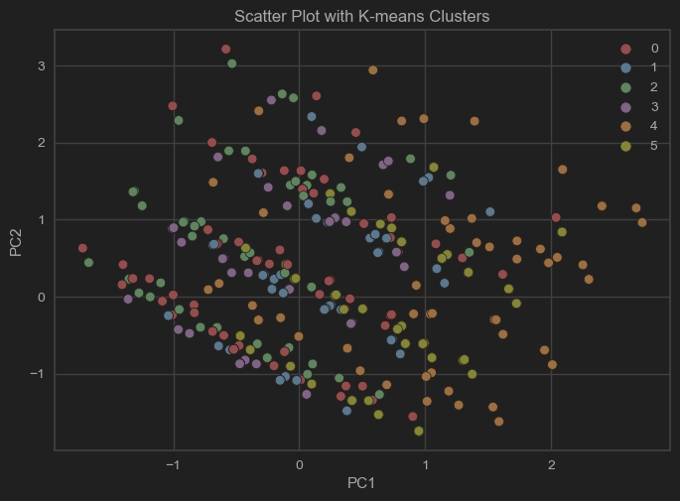

* + **Hierarchical Clustering**

We also applied Hierarchical clustering to the PCA-transformed data. The `apply_hierarchical_clustering` function performed the clustering and displayed a dendrogram representing the hierarchical structure of the clusters. Additionally, we plotted a scatter plot of the data points coloured by their cluster assignments. We determined the number of clusters by specifying a distance threshold above which we would not merge clusters.

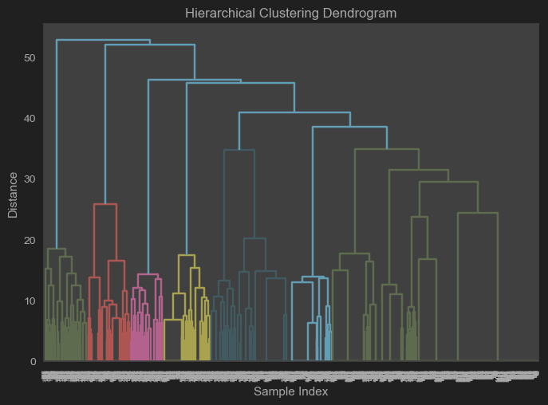

* *Cluster Analysis*

After obtaining the clusters, we analysed their distribution and percentages using the `analyze_clusters` function. The function provided a bar chart showing the number of data points in each cluster. Additionally, we computed the percentage of data points in each cluster to assess their relative sizes.

In conclusion, the clustering analysis on the McDonald’s customer dataset revealed distinct groups of customers based on their preferences and characteristics. The K-means clustering algorithm and Hierarchical clustering algorithm identified similar clusters, indicating the robustness of the results. The analysis yielded valuable insights into customer segmentation, which businesses can utilise for targeted marketing campaigns, menu optimisation, and personalised promotions. However, it is important to note that the analysis relies on the available dataset, and further exploration and validation may be necessary to achieve more accurate clustering.

You can find the code for this analysis on GitHub: <https://github.com/A2162014/Feynn-Labs-Project-2.git>

**10. Conclusion:**

In conclusion, this market segmentation study has provided valuable insights into understanding our target market and has paved the way for effective marketing strategies. Through the thorough analysis of data and the identification of distinct segments, I have gained a deeper understanding of our customers and their preferences.

The key findings of this market segmentation study include the following:

* *Identification of Target Segments:*

By analysing the data, we have identified several distinct segments within our target market. These segments exhibit unique characteristics, behaviours, and preferences, enabling us to tailor our marketing efforts to their needs.

* *Understanding Customer Needs:*

Through the segmentation process, we have comprehensively understood our customers’ needs, desires, and pain points. This understanding allows for developing targeted marketing messages and delivering personalised experiences that resonate with each Segment.

* *Improved Marketing Effectiveness:*

By segmenting the market, we can allocate resources more effectively and focus marketing efforts on the segments offering the most remarkable growth and profitability potential. This targeted approach maximises the impact of marketing campaigns and generates better returns on investment.

* *Enhanced Customer Engagement and Satisfaction:*

The segmentation findings enable the development of tailored products, services, and marketing strategies that meet the specific requirements of each Segment. Enhancing customer satisfaction by addressing their unique needs and preferences fosters stronger relationships and builds customer loyalty.

* *Competitive Advantage:*

We gain a competitive advantage through market segmentation by understanding the distinct segments within our market and customising offerings to match their preferences, which allows differentiation from competitors and positions us as the preferred choice for our target customers.

The insights gained from this market segmentation study will guide our marketing strategies and decision-making. We will leverage the identified segments to develop targeted campaigns, refine our product offerings, and enhance customer experiences. Additionally, continuous monitoring and evaluation of market dynamics will be crucial to adapt the segmentation strategy as the market evolves.

In conclusion, market segmentation is a powerful tool to understand our customers better and tailor our marketing strategies to meet their needs. By focusing on these segments, we can create meaningful connections, drive business growth, and achieve sustainable success in our target market.